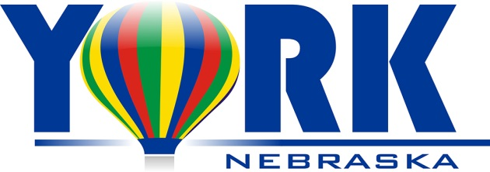 | Adopt–A-Park  Application Form

Name of Volunteer Organization ___________________________________________________________________

Mailing Address______________________________________________________________________________________

List the City Park that you are interested in cleaning (in order of preference)

1. ________________________________________________________________________________________________________

2. ______________________________________________________________________________________________________

3.______________________________________________________________________________________________________

Please note that City Parks are assigned on a “first come, first serve” basis. If the sections your group has identified are unavailable, the City of York Public Works Department will suggest alternatives.

Signature of Organization Representative___________________________________________________________________

Name of Volunteer Organization Representative (please print) ________________________________________

Phone Number____________________________________________________________________________________________

Mailing Address____________________________________________________________________________________________

Email Address___________________________________________________________________________________________

Return this application to: City of York
Adopt a Park Program
PO Box 507
York, NE 68467

